Concentric Curves

Definition
# Source: AI Source: Provided by: [Data Path: Persons Table -> ID Column: 1, Name_En Column: Motasem Essam] -> From: [ChatGPT] on [7/25/2026]
Concentric Curves are two or more curves that share a common center or central point of reference while occupying different sizes or positions around that center.
The term is most commonly used for curves with a clearly defined center, such as circles, but it can also be used descriptively for other centrally organized curves.
For a family of concentric curves centered at $O$:
$$O_{1}=O_{2}=⋯=O_{n}=O$$
The curves differ in their size, scale, or distance from the common center.
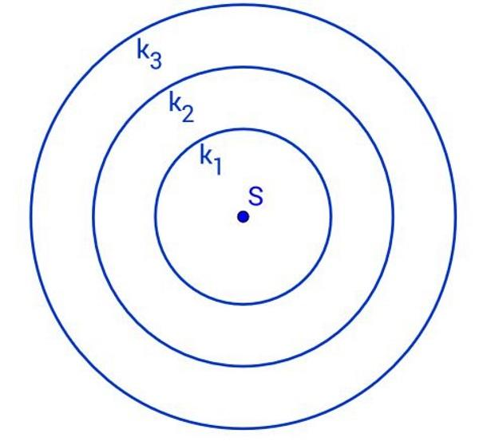
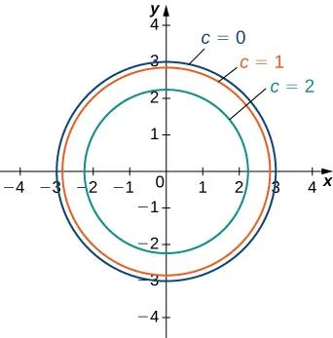
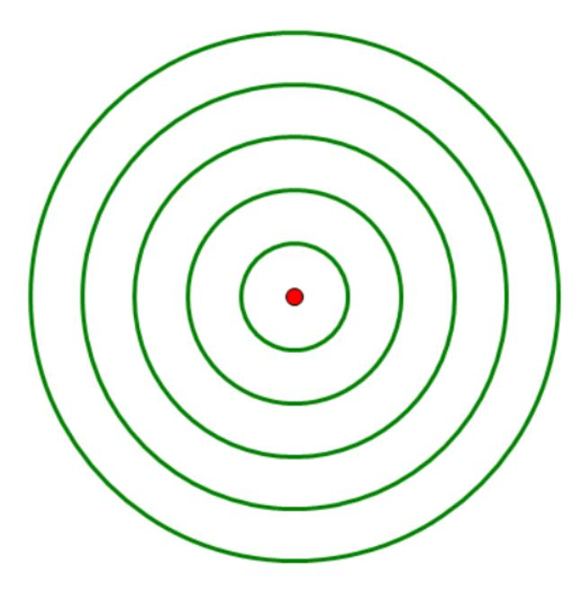

Fundamental Concept
# Source: AI Source: Provided by: [Data Path: Persons Table -> ID Column: 1, Name_En Column: Motasem Essam] -> From: [ChatGPT] on [7/25/2026]
The essential idea is:
Common center + different-sized curves
For two concentric curves:
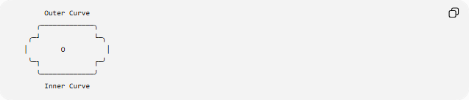
Outer Curve
╭─────────────╮
╭─┘ └─╮
│ O │
╰─┐ ┌─╯
╰─────────────╯
Inner Curve
The point $O$is the common center.
Unlike ordinary nested curves, concentric curves are specifically organized with respect to the same central point.

Main Characteristics
# Source: AI Source: Provided by: [Data Path: Persons Table -> ID Column: 1, Name_En Column: Motasem Essam] -> From: [ChatGPT] on [7/25/2026]
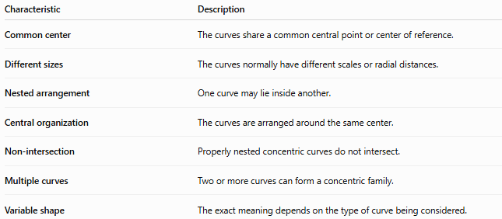
Characteristic | Description
Common center | The curves share a common central point or center of reference.
Different sizes | The curves normally have different scales or radial distances.
Nested arrangement | One curve may lie inside another.
Central organization | The curves are arranged around the same center.
Non-intersection | Properly nested concentric curves do not intersect.
Multiple curves | Two or more curves can form a concentric family.
Variable shape | The exact meaning depends on the type of curve being considered.

Basic Structure
# Source: AI Source: Provided by: [Data Path: Persons Table -> ID Column: 1, Name_En Column: Motasem Essam] -> From: [ChatGPT] on [7/25/2026]
For a family of $n$concentric curves:
$$C_{1},C_{2},…,C_{n}$$
with common center $O$:
$$O\left(C_{1}\right)=O\left(C_{2}\right)=⋯=O\left(C_{n}\right)=O$$
If they are nested:
$$C_{1}⊂C_{2}⊂⋯⊂C_{n}$$
where the notation describes their enclosed regions when the curves are closed.

Types of Concentric Curves
# Source: AI Source: Provided by: [Data Path: Persons Table -> ID Column: 1, Name_En Column: Motasem Essam] -> From: [ChatGPT] on [7/25/2026]
Concentric curves can be classified according to the type of curve involved.
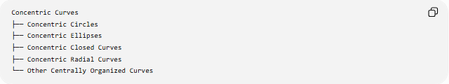
Concentric Curves
├── Concentric Circles
├── Concentric Ellipses
├── Concentric Closed Curves
├── Concentric Radial Curves
└── Other Centrally Organized Curves
The most mathematically standard example is concentric circles.

Concentric Circles
# Source: AI Source: Provided by: [Data Path: Persons Table -> ID Column: 1, Name_En Column: Motasem Essam] -> From: [ChatGPT] on [7/25/2026]
Two or more circles are concentric when they have exactly the same center.
For circles with center $O=\left(h , k\right)$:
$${\left(x-h\right)}^{2}+{\left(y-k\right)}^{2}=r_{1}^{2}$$
and
$${\left(x-h\right)}^{2}+{\left(y-k\right)}^{2}=r_{2}^{2}$$
The centers are identical:
$$O_{1}=O_{2}=\left(h , k\right)$$
but:
$$r_{1}≠r_{2}$$
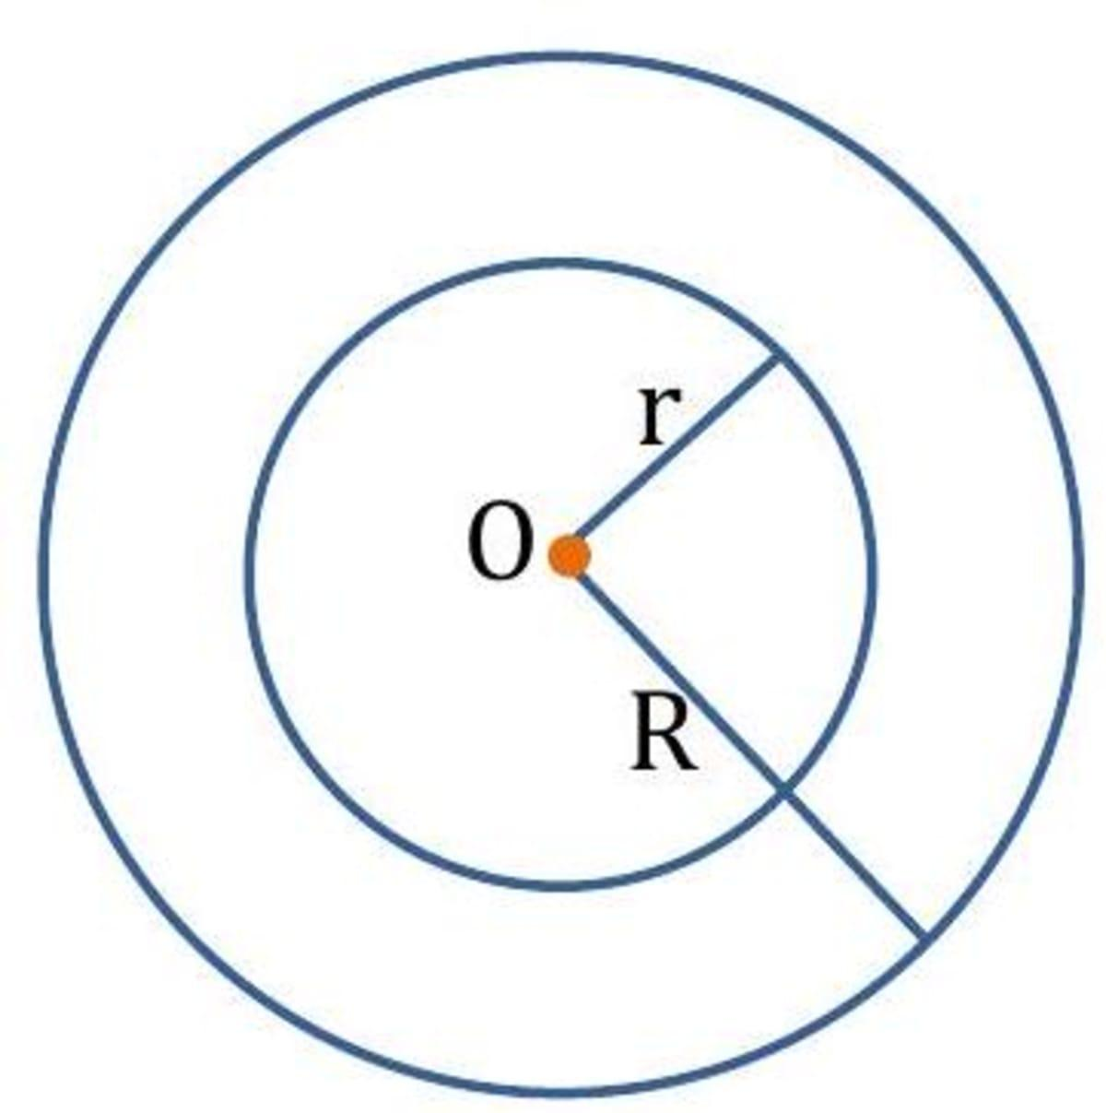
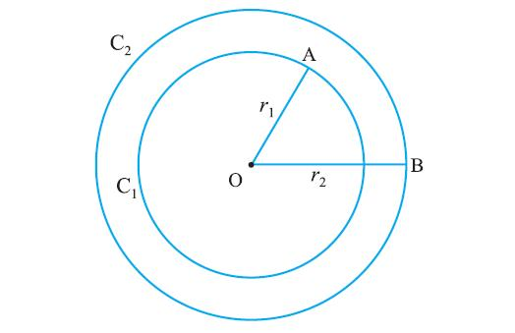
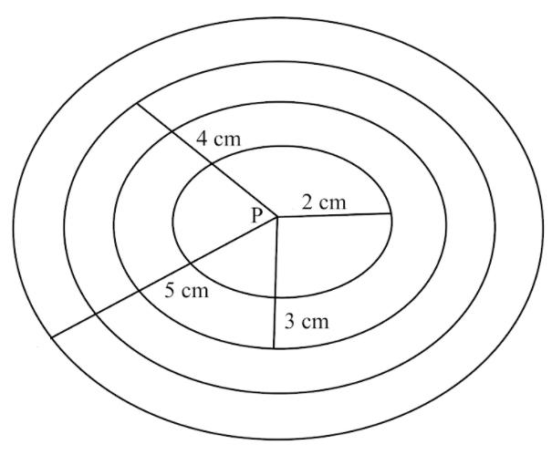

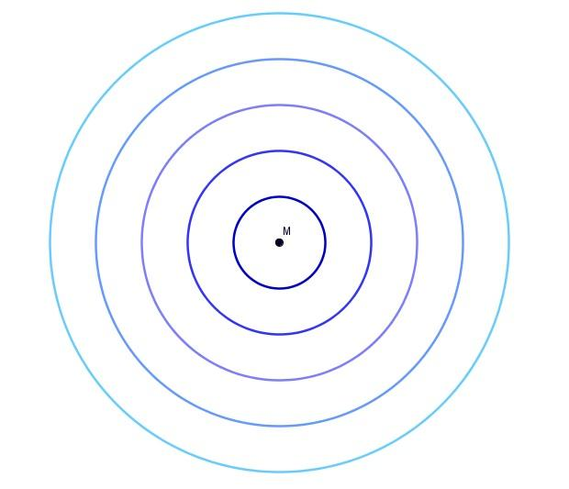
Concentric circles are the clearest and most standard example of concentric curves.

Concentric Ellipses
# Source: AI Source: Provided by: [Data Path: Persons Table -> ID Column: 1, Name_En Column: Motasem Essam] -> From: [ChatGPT] on [7/25/2026]
Concentric ellipses are ellipses that share the same center.
For an axis-aligned ellipse centered at $\left(h , k\right)$:
$$\frac{{\left(x-h\right)}^{2}}{a^{2}}+\frac{{\left(y-k\right)}^{2}}{b^{2}}=1$$
Two concentric ellipses can therefore be written as:
$$\frac{{\left(x-h\right)}^{2}}{a_{1}^{2}}+\frac{{\left(y-k\right)}^{2}}{b_{1}^{2}}=1$$
and
$$\frac{{\left(x-h\right)}^{2}}{a_{2}^{2}}+\frac{{\left(y-k\right)}^{2}}{b_{2}^{2}}=1$$
Both have the same center:
$$\left(h , k\right)$$
but different semi-axis lengths.
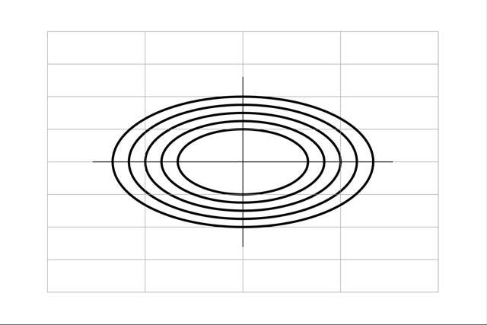
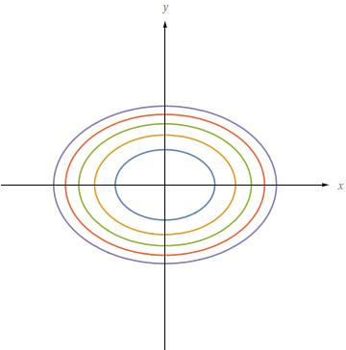
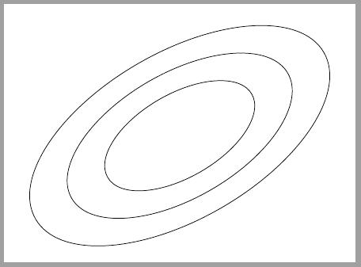
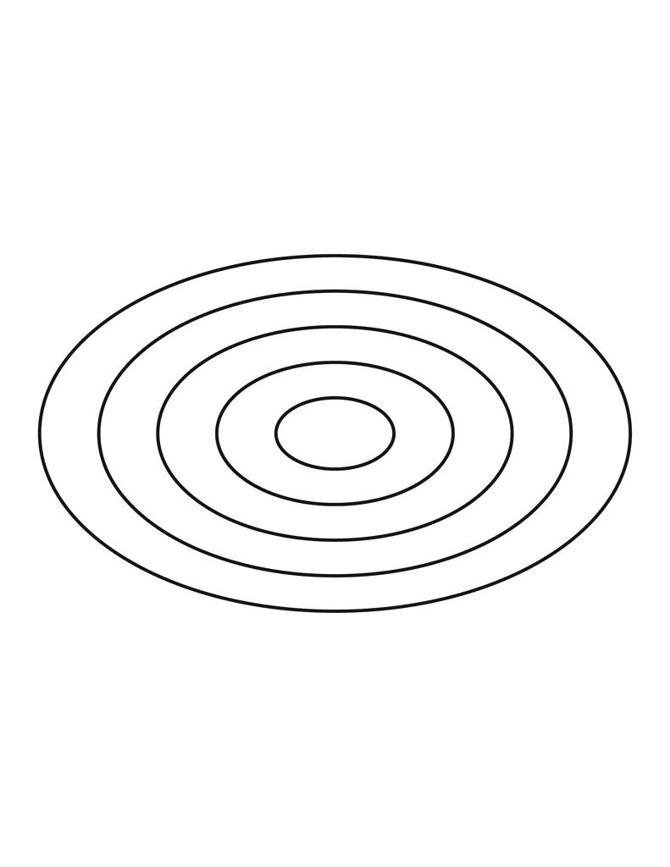
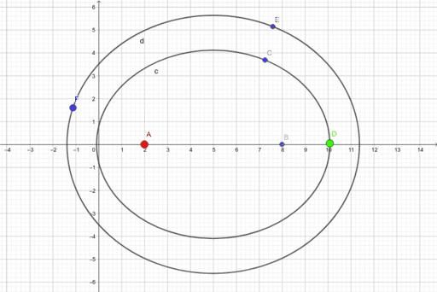
If the ellipses have the same axis directions and proportional semi-axes:
$$\frac{a_{2}}{a_{1}}=\frac{b_{2}}{b_{1}}$$
they are scaled versions of one another.

Concentric Closed Curves
# Source: AI Source: Provided by: [Data Path: Persons Table -> ID Column: 1, Name_En Column: Motasem Essam] -> From: [ChatGPT] on [7/25/2026]
A broader descriptive category is concentric closed curves.
These are closed curves arranged around a common center.
Examples can include:
- Concentric circles
- Concentric ellipses
- Centrally scaled closed curves
A general closed curve can be represented parametrically as:
$$r\left(t\right)=\left(x , \left(t\right)y\left(t\right)\right)$$
with:
$$r\left(a\right)=r\left(b\right)$$
for a closed curve.
If several such curves are generated by scaling around the same center $O$, they form a concentric family.

Concentric Curves by Scaling
# Source: AI Source: Provided by: [Data Path: Persons Table -> ID Column: 1, Name_En Column: Motasem Essam] -> From: [ChatGPT] on [7/25/2026]
One important way to construct concentric curves is through dilation.
If a curve $C$is centered at $O$, a scaled version can be written as:
$$C_{k}=O+k\left(C-O\right)$$
where $k>0$is the scale factor.
For two curves:
$$C_{2}=D_{O,k}\left(C_{1}\right)$$
This means the second curve is obtained by scaling the first around the common center $O$.
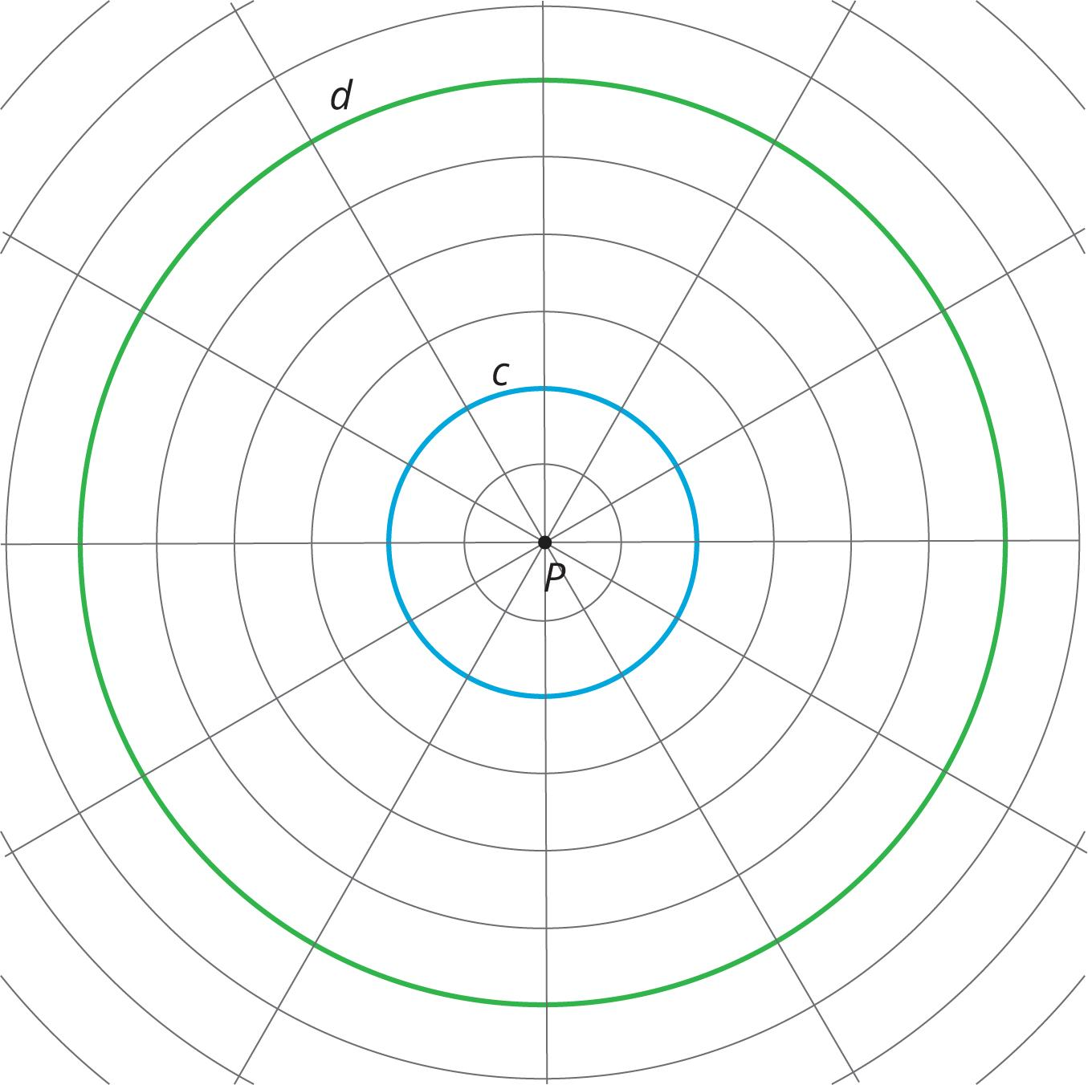
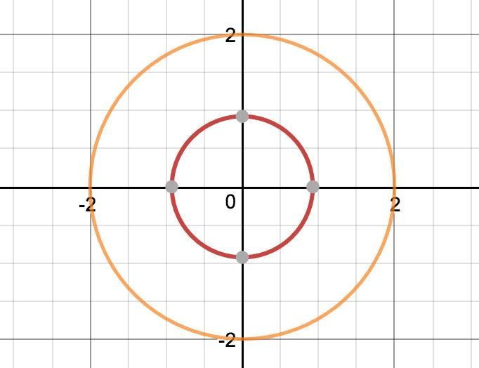
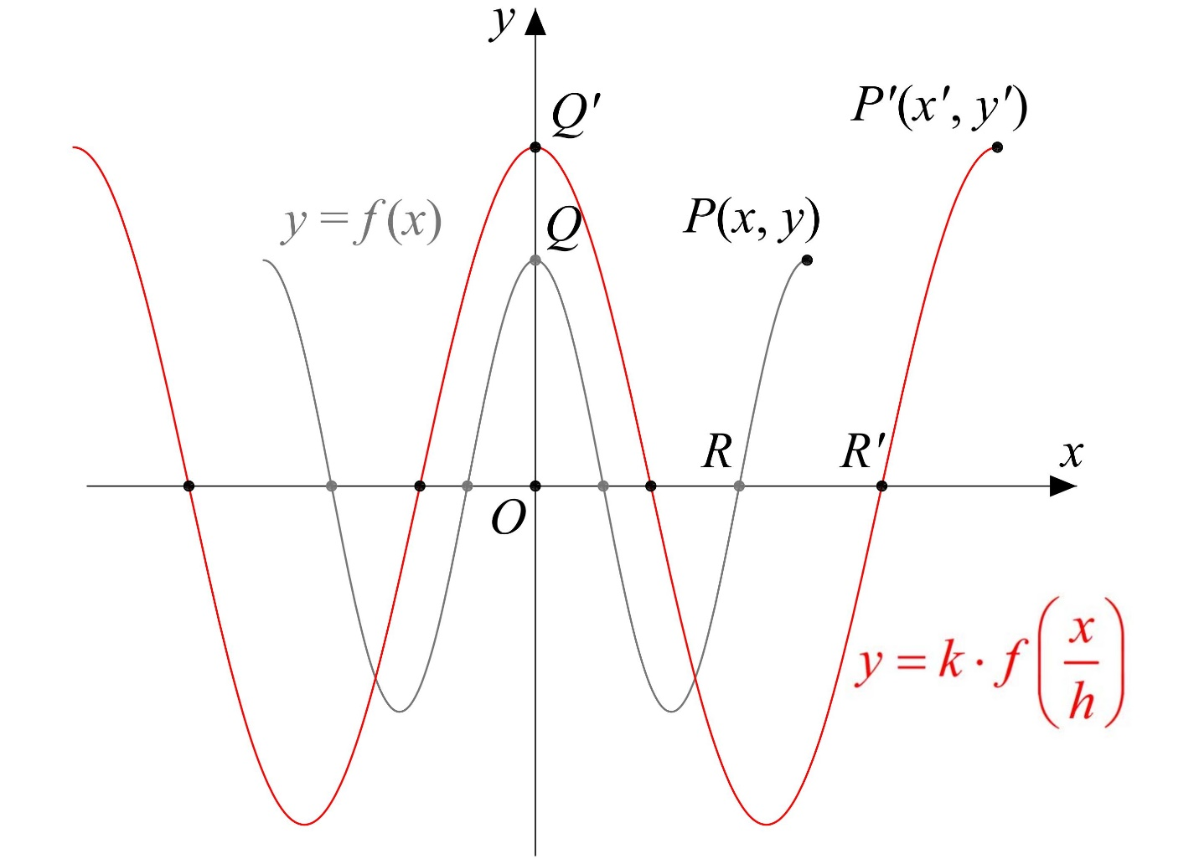
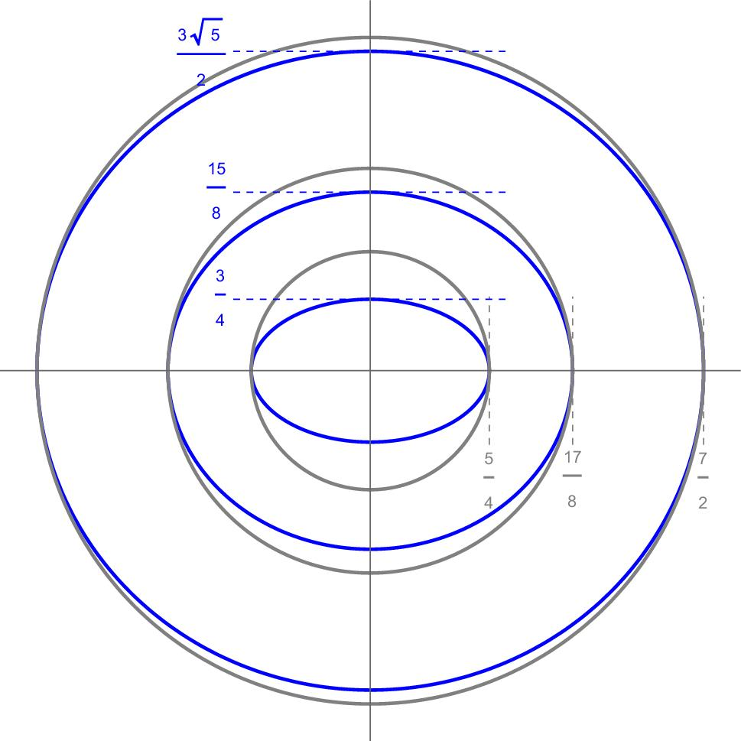
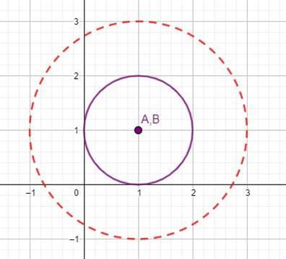

Mathematical Representation
# Source: AI Source: Provided by: [Data Path: Persons Table -> ID Column: 1, Name_En Column: Motasem Essam] -> From: [ChatGPT] on [7/25/2026]
For a centrally symmetric radial curve, a polar equation can be useful:
$$r=f\left(θ\right)$$
A scaled family can be represented by:
$$r=kf\left(θ\right)$$
where $k$determines the size of the curve.
For example:
$$r=2f\left(θ\right)$$
and
$$r=4f\left(θ\right)$$
represent two curves sharing the same central reference point.

Distance Between Concentric Curves
# Source: AI Source: Provided by: [Data Path: Persons Table -> ID Column: 1, Name_En Column: Motasem Essam] -> From: [ChatGPT] on [7/25/2026]
For circles, the radial separation between two concentric circles is exactly:
$$d=R-r$$
For more general concentric curves, however, the distance between their boundaries does not necessarily remain constant.
This is an important distinction.
Circles
$$d=R-r$$
is constant in every direction.
Ellipses
The separation between two concentric ellipses can vary depending on direction.
Therefore:
Concentric does not necessarily mean equally spaced.

Concentric Curves vs. Concentric Circles
# Source: AI Source: Provided by: [Data Path: Persons Table -> ID Column: 1, Name_En Column: Motasem Essam] -> From: [ChatGPT] on [7/25/2026]
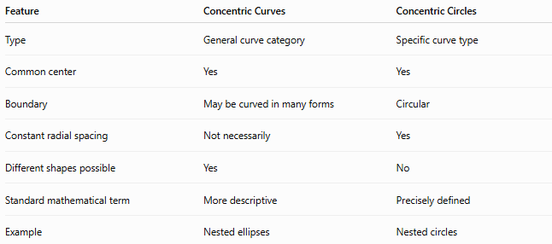
Feature | Concentric Curves | Concentric Circles
Type | General curve category | Specific curve type
Common center | Yes | Yes
Boundary | May be curved in many forms | Circular
Constant radial spacing | Not necessarily | Yes
Different shapes possible | Yes | No
Standard mathematical term | More descriptive | Precisely defined
Example | Nested ellipses | Nested circles

Concentric Curves vs. Nested Curves
# Source: AI Source: Provided by: [Data Path: Persons Table -> ID Column: 1, Name_En Column: Motasem Essam] -> From: [ChatGPT] on [7/25/2026]
These concepts should not be treated as identical.
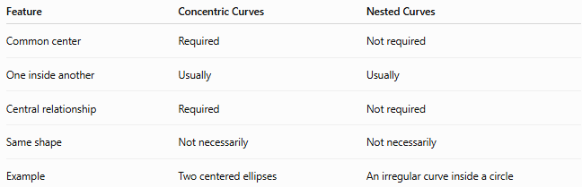
Feature | Concentric Curves | Nested Curves
Common center | Required | Not required
One inside another | Usually | Usually
Central relationship | Required | Not required
Same shape | Not necessarily | Not necessarily
Example | Two centered ellipses | An irregular curve inside a circle
A curve can be nested inside another curve without being concentric.

Concentric Curves vs. Similar Curves
# Source: AI Source: Provided by: [Data Path: Persons Table -> ID Column: 1, Name_En Column: Motasem Essam] -> From: [ChatGPT] on [7/25/2026]
Similarity and concentricity describe different properties.
Two curves may be scaled copies of each other but have different centers.
Conversely, two curves may share a center without being similar.
For example, two ellipses can share the same center but have different proportions:
$$\frac{a_{1}}{b_{1}}≠\frac{a_{2}}{b_{2}}$$
They can therefore be concentric without being similar.

Examples

Example 1 — Concentric circles
# Source: AI Source: Provided by: [Data Path: Persons Table -> ID Column: 1, Name_En Column: Motasem Essam] -> From: [ChatGPT] on [7/25/2026]
Two circles have:
$$O=\left(0 , 0\right)$$
with radii:
$$r_{1}=3, r_{2}=7$$
Since both have the same center:
$$O_{1}=O_{2}=\left(0 , 0\right)$$
they are concentric.
Their radial separation is:
$$d=7-3=4$$

Example 2 — Concentric ellipses
# Source: AI Source: Provided by: [Data Path: Persons Table -> ID Column: 1, Name_En Column: Motasem Essam] -> From: [ChatGPT] on [7/25/2026]
Consider:
$$\frac{x^{2}}{16}+\frac{y^{2}}{9}=1$$
and:
$$\frac{x^{2}}{64}+\frac{y^{2}}{36}=1$$
Both have center:
$$\left(0 , 0\right)$$
The second ellipse is a scaled version of the first with scale factor:
$$k=2$$
Therefore, they form a concentric family.

Classification Summary
# Source: AI Source: Provided by: [Data Path: Persons Table -> ID Column: 1, Name_En Column: Motasem Essam] -> From: [ChatGPT] on [7/25/2026]
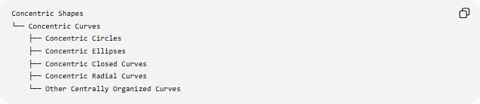
Concentric Shapes
└── Concentric Curves
├── Concentric Circles
├── Concentric Ellipses
├── Concentric Closed Curves
├── Concentric Radial Curves
└── Other Centrally Organized Curves
Another useful classification is by the number of curves:
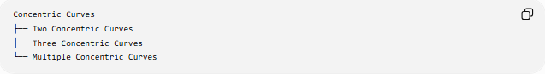
Concentric Curves
├── Two Concentric Curves
├── Three Concentric Curves
└── Multiple Concentric Curves

Key Points
# Source: AI Source: Provided by: [Data Path: Persons Table -> ID Column: 1, Name_En Column: Motasem Essam] -> From: [ChatGPT] on [7/25/2026]
- Concentric curves share a common center or central reference point.
- The curves normally have different sizes or scales.
- Concentric circles are the most standard and precise example.
- Concentric ellipses can share the same center while having different semi-axis lengths.
- Concentric curves do not necessarily have a constant distance between their boundaries.
- Concentricity is different from simply being nested.
- Concentricity is also different from similarity.
- Dilation centered at the common center is a common way to generate concentric curves.
- The term becomes more descriptive and less standardized as the curve type becomes more general.

Conclusion
# Source: AI Source: Provided by: [Data Path: Persons Table -> ID Column: 1, Name_En Column: Motasem Essam] -> From: [ChatGPT] on [7/25/2026]
Concentric Curves are curves organized around a common center, usually with different sizes or scales. Concentric circles provide the clearest mathematical example, while concentric ellipses and other centrally organized curves extend the concept. The key distinction is that concentricity describes a common central organization, not necessarily equal spacing, identical shape, or similarity.

